Requirements

The overlap of irregular classes is not very important.

We should start creating the course schedule by focusing on the first-year courses because there are many common classes.

The possibility of opening a second section should always be taken into account.

The service courses for academics should also be considered.

When determining lab class hours, we should also ensure that there is a suitable lab room available within the specified time frame.

Placing common courses first and then curriculum courses helps prevent conflicts.

There should be no conflicts among elective courses in the fourth year.

It should be noted that situations such as students taking courses from higher or lower levels should be considered, but it is not our top priority.

Since there will be two sections for the labs, we should designate two different lab sections and schedule them in a way that they do not overlap, ensuring that they are placed on days following the theoretical classes

Care should be taken to ensure that third-year students can select their technical elective courses.

A maximum of 40 people can be in the lab.

No classes should be scheduled on Friday from 13:20 to 15:10.

The CENG elective course schedule should be taken into account, and conflicts with technical electives should be minimized.

Lab classes should be scheduled before theoretical classes.

Each faculty member should be scheduled for a maximum of 4 hours of classes, including graduate courses, within one day.

The class schedule for external instructor can be planned with exceptions to the day and hour restrictions

USE CASE DIAGRAM

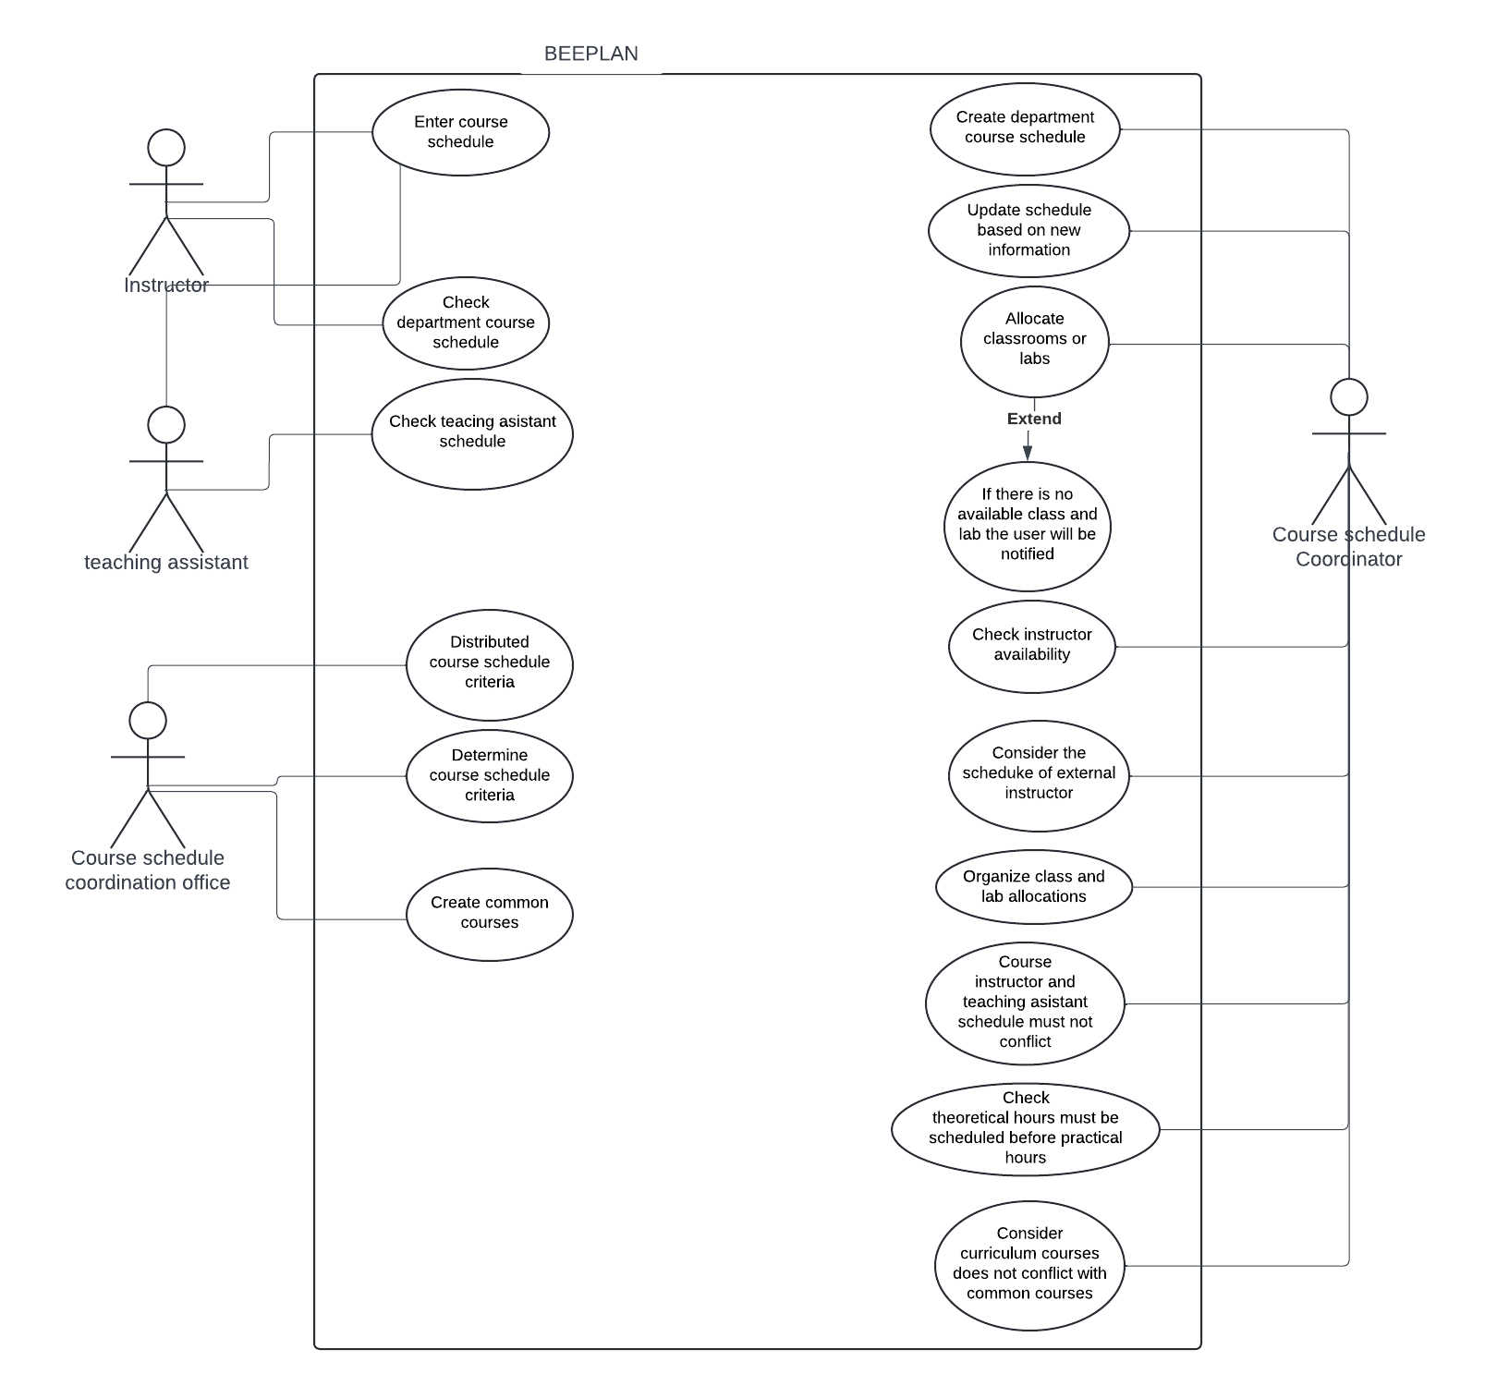

Activity Diagram

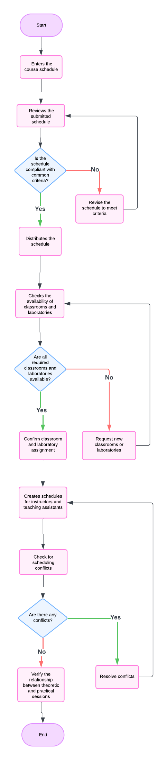

Sequence Diagram

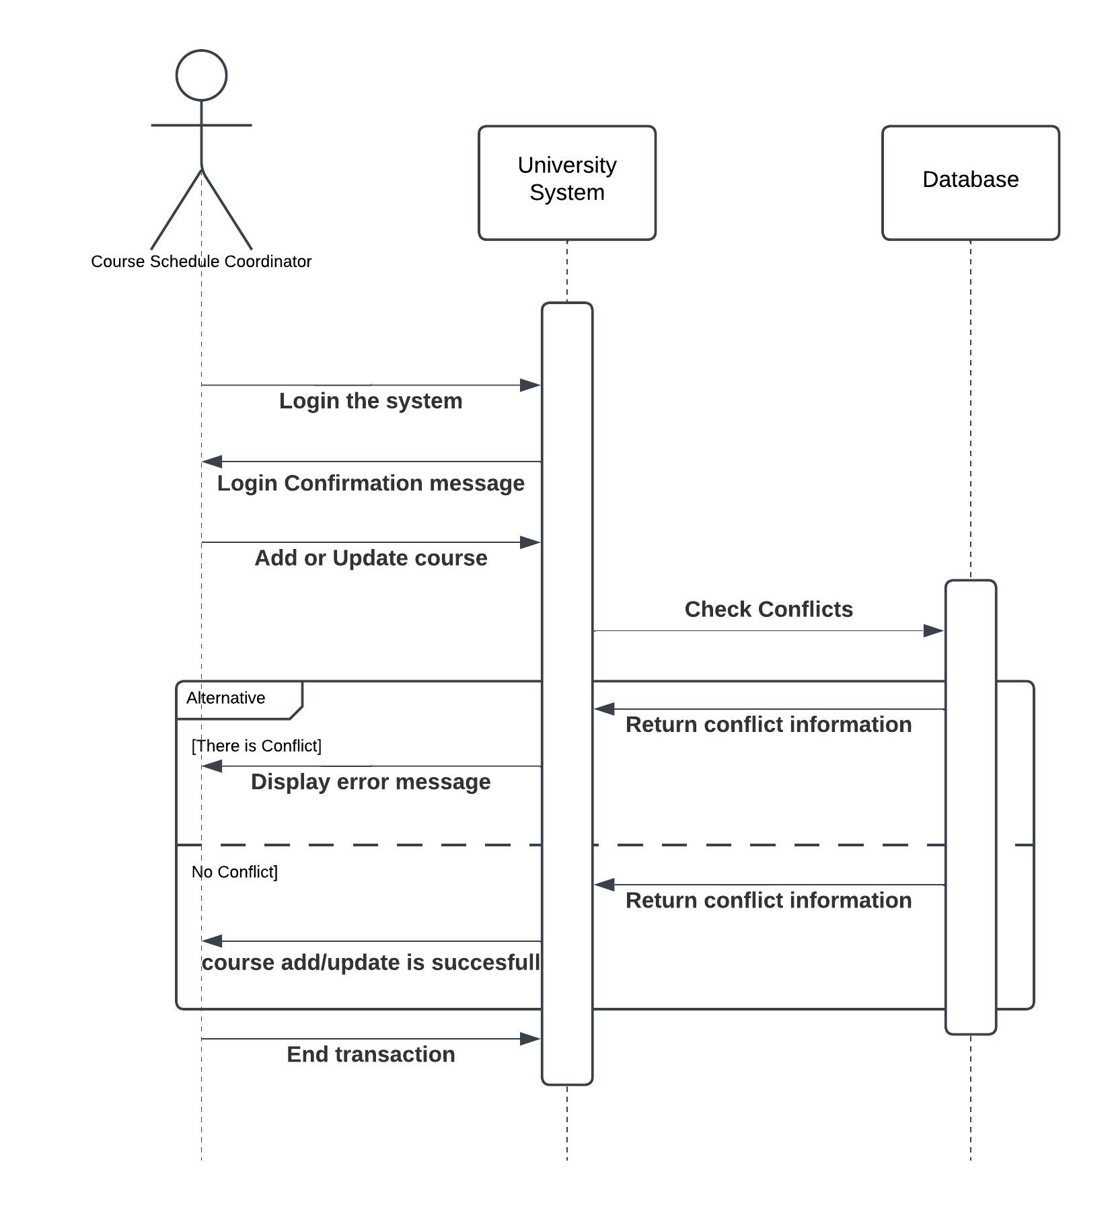

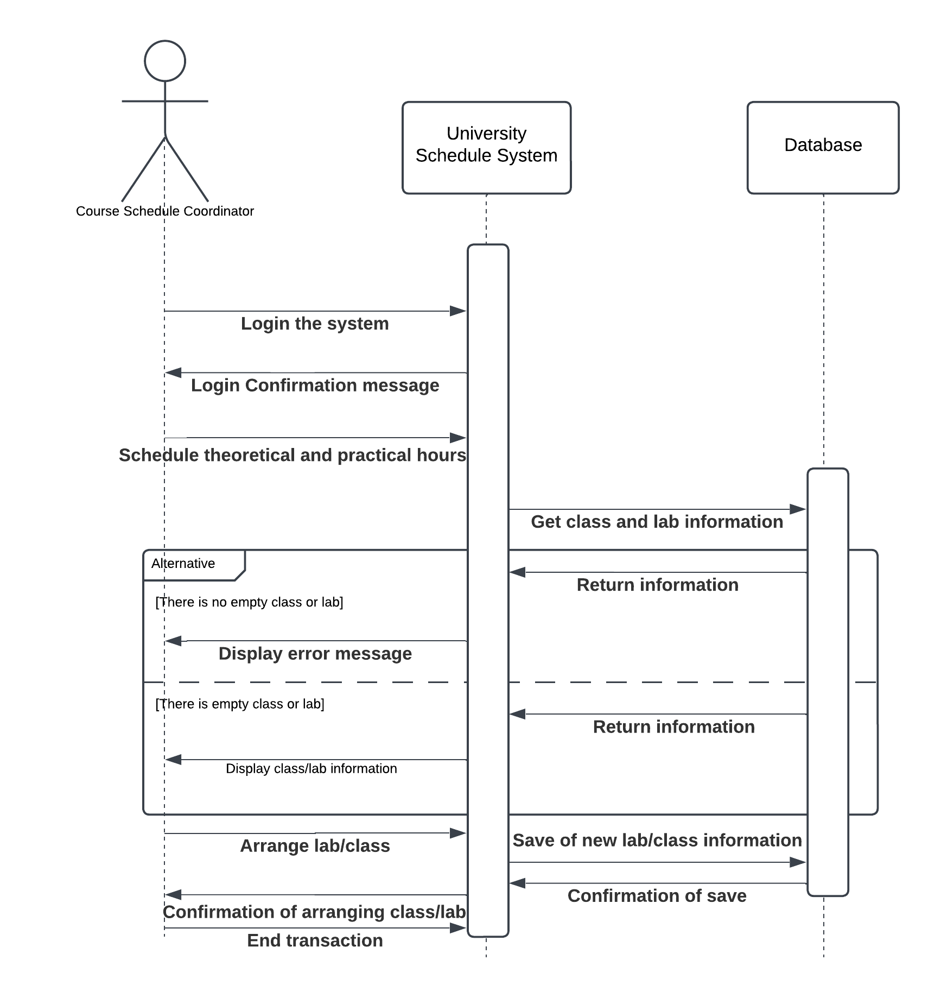

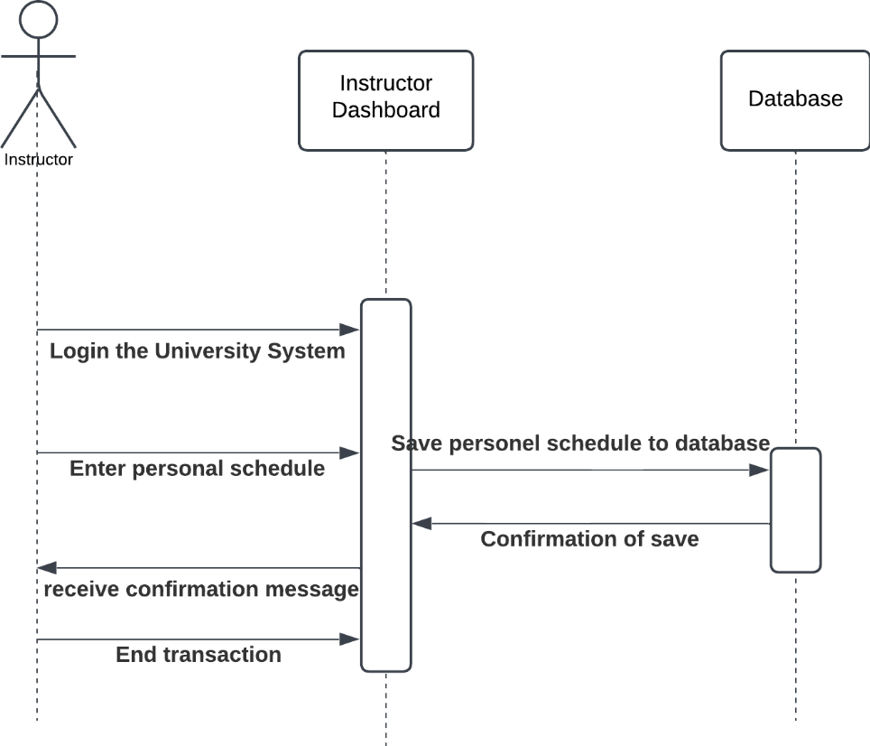

Class Diagram

